TRUTH TABLE GENERATOR

BY :-
Arnav Vithlani
Krish Khajuria

Academic Project

- Introduction

The Truth Table Generator is a web application that gives a user the ability to evaluate expressions and display their truth tables. For this, it relies on HTML, CSS, and JavaScript. The application operators include OR and NOT operators. This allows users to evaluate logical formulas for all possible input values. The Truth Table Generator features a JavaScript expression parser and a responsive themed UI. Expressions can be built with any number of variables via a custom keyboard that appears on the screen. The result is dynamically generated in the browser in the form of a truth table. This project exemplifies the use of concepts from mathematics, Boolean algebra, to a functioning web application.

- Motivation

The biggest motivator behind the creation of the Truth Table Generator was how repetitive and error-prone it was to create truth tables by hand. It’s difficult for students to verify if their logical expressions evaluate correctly for every possible input combination. The Truth Table Generator automates this process so that anyone can easily validate expressions without using calculations. The final product is meant to be a simple-to-use web tool that does not require any installation or outside dependencies. This is a case study in practical application of a theoretical mathematical concept to web development.

- Applicability

The Truth Table Generator is a web application for evaluating logic expressions. This proved the main issue, which was the work needed to create truth tables for formulas, which is key in circuit design and the study of logic. The application under consideration addresses these challenges. All variables in a given expression in time are automatically detected. All permutations of TRUE/FALSE values for n-vars with the bitwise math. Safe evaluation of the expression for each row, using a custom JavaScript execution engine. Displaying results in a color-coded table using DOM manipulation.

- Background theory/tools used

Theory : The logic engine of the truth table generator is Boolean algebra. The Boolean algebra deals with the variables, which have two values: TRUE or FALSE. The truth table generator supports the following basic operations: AND: only when both A and B are TRUE. OR: TRUE if at least one operand is TRUE. NOT: Negates the truth value of A.

Tools used : VSCode, ChatGPT.

- Your work

The Truth Table Generator project is a fully front-end web application. Hence, it operates wholly on the client’s browser. The application has three components: Logic Engine: This part monitors keystrokes in time, parses expressions, extracts variables, generates mathematical rows, and evaluates strings. User Interface: The UI is a card-based display on a dark gradient background. There is a text input field and a keyboard on the screen in addition to badges that identify variables in use and an HTML table that may be changed dynamically. DOM Manipulation & Styling: JavaScript is used to add elements into a document. Output values are associated with CSS classes for the sake of readability. In this way, building of the truth table generator reflected the use of discrete mathematics in the web development field. This project was a match to frontend software engineering practice. The key concepts learned from this project are From Theory to Web Code: We learned how to link math concepts to a working JavaScript application. Bitwise Mathematics: Practiced in the use of low-level bitwise shift operators in JavaScript. DOM Manipulation: We became better at creating, changing, and styling HTML elements dynamically. This Truth Table Generator tool is for all those who require checking their logical expressions and getting their truth tables. Also, it is user-friendly. There is no need for any installations or external dependencies. This truth table generator is an example of applying a math concept into a working web application.

- Code

The JavaScript algorithm of the truth table generator works in the following way: Using regular expressions, extract all the names from the input expression. Calculate the number of rows required by 2^n combinations. Assign TRUE/FALSE values to each variable for every row using bitwise right-shift operations. Pre-process the user string, substituting operators with JavaScript logical operators. Each row must be rendered to the HTML table after safely evaluating the output string using the JavaScript Function() constructor.

HTML :
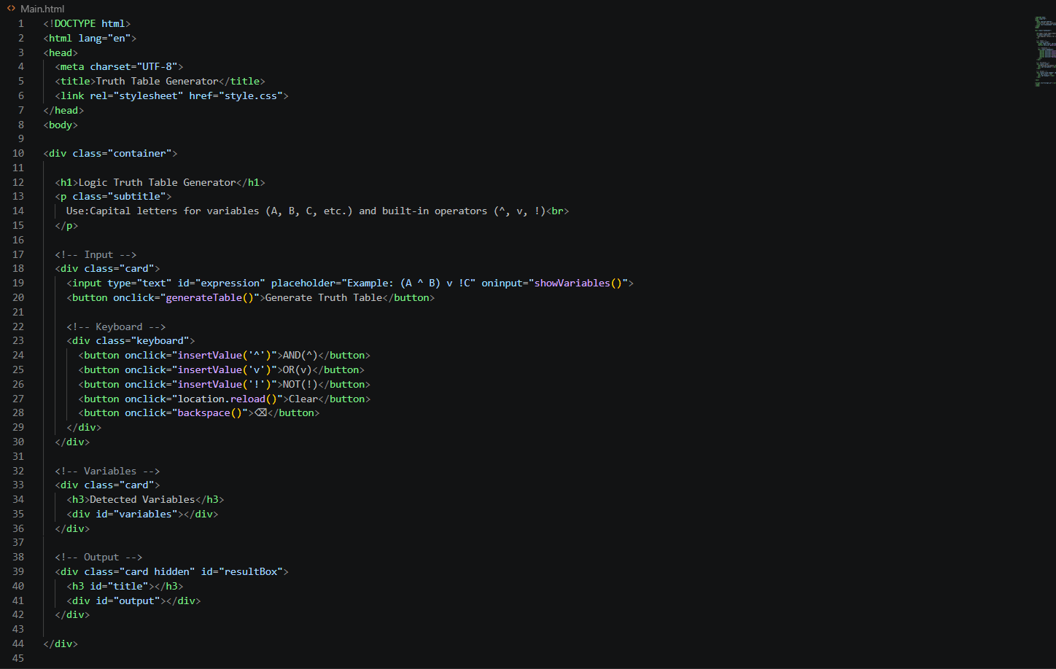

CSS :
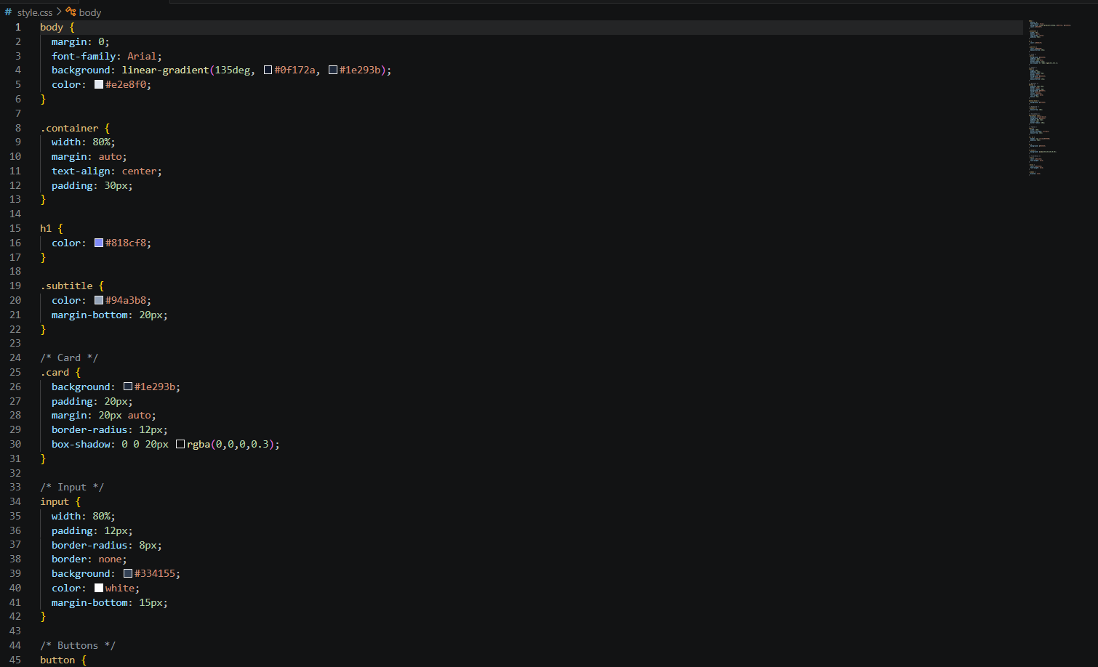

JS :
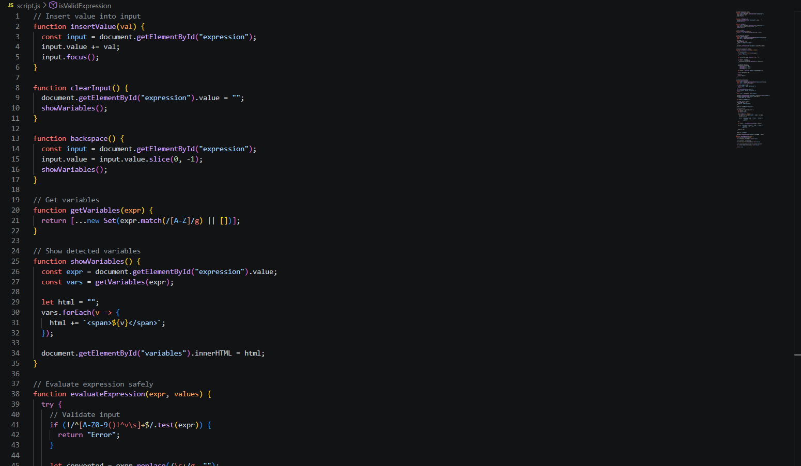

- Output snippets

Truth Table Generator has prototype screenshots:
Screenshot 1: Main Application Window.
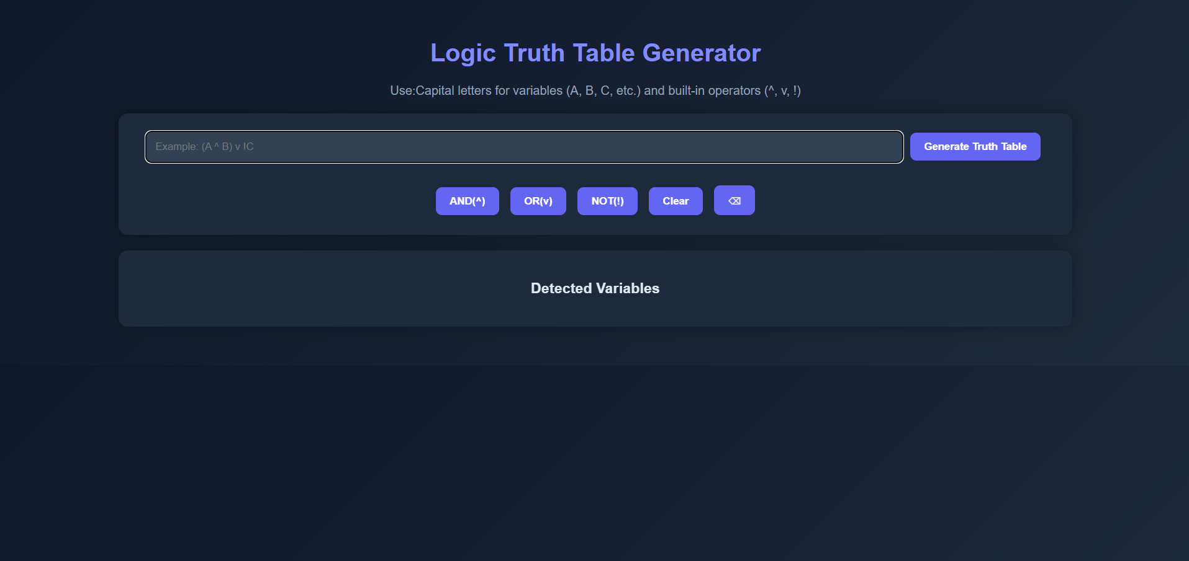 The responsive web GUI includes the input field, the custom interactive keyboard for logic operation, and the ‘Detected variables’ display area.

Screenshot 2: Generated Truth Table Output
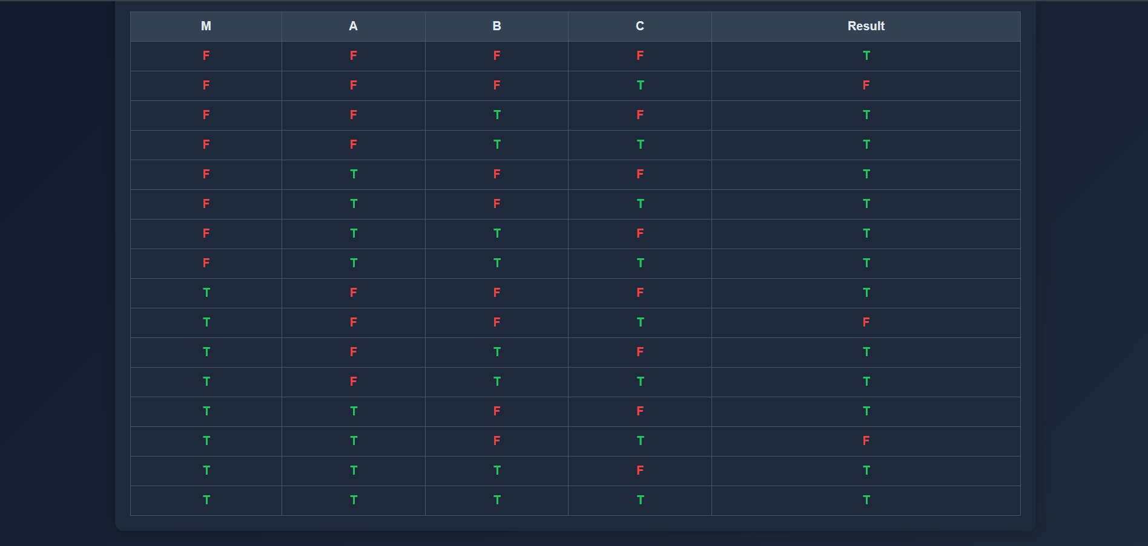A dynamically generated sample truth table. FALSE values are represented in red, and TRUE values appear in green.

- Role of each member in the team

The individual group member contributions are Krish Khajuria, the Core Logic Developer, was responsible for creating the JavaScript logic engine of the expression parser and evaluation of dynamic strings. For generating the 2^n binary row combinations, he used the bitwise algorithm. He also wired the HTML input fields to the JavaScript logic using event listeners, implementing try…catch safety features to mitigate application crashes from inputs. Arnav Vithlani, UI/CSS Designer, created the themed user interface with CSS styling and hover effects. Finally, he used color-coding logic to make the data more readable.

